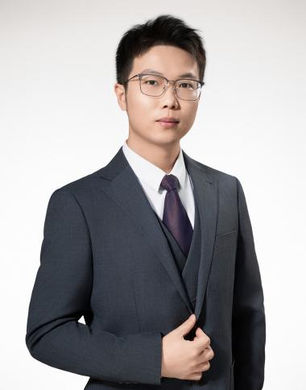

**Zhikai Wang Lawyer**

**Expertise：Dispute resolution**

**Tel：+86 10 8587 0068**

**Fax：+86 10 8587 0079**

**Email：zhikai.wang@chancebridge.com**

**Areas of Practice**

Zhikai Wang professional areas mainly include civil and commercial litigation and arbitration, construction projects and real estate, labor disputes, corporate compliance, etc. Before joining Zhuowei Law Firm, Wang Zhikai had worked at Shanghai Jianwei (Beijing) Law Firm, an environmental technology company, and Qingdao Urban Company of Longfor Group.

**Education background**

* Renmin University of China, majoring in Civil and Commercial Law (currently studying)
* Harbin Institute of Technology, Master of Landscape Architecture
* University of Padua, majoring in Urban Design (exchange student)
* Northeast Forestry University, Bachelor of Engineering

**Work Experience**

* Since March 2025, joined the Dispute Resolution Department of Chance Bridge Law Firm
* City Development Law Firm of Beijing
* An environmental technology company
* Qingdao Urban Company of Longfor Group

**Representative Matters**



**Publications**

**Professional Activities**

**Recognition**



**Language**

Chinese, English