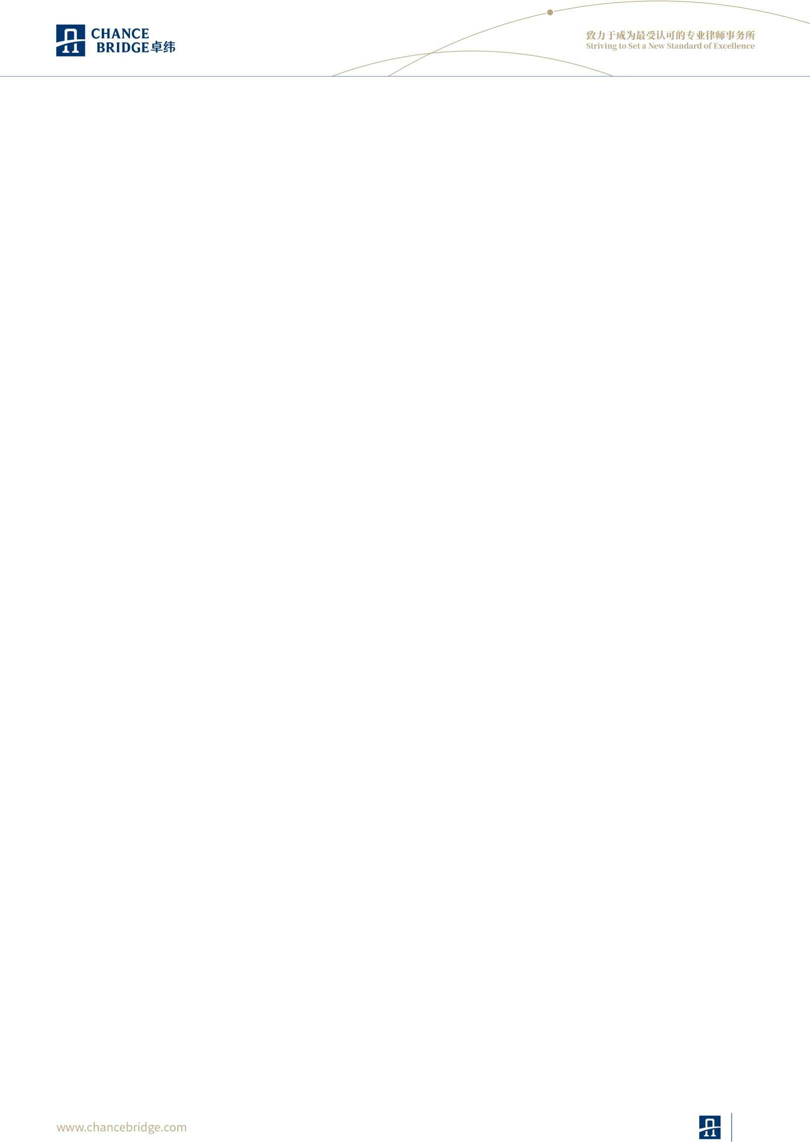

**Shuang Liang paralegal**

**Expertise**：**International Trade and Compliance, Intellectual property**

**Tel**：**+86 15201910833**

**Fax**：**+86 10 8587 0079**

**Email**：**shuang.liang @chancebridge.com**

# Areas of Practice

During Shuang’s professional tenure in New York, she demonstrated outstanding competence in various fields, including litigation, family law, real estate, trusts, and estate planning. She provided comprehensive support for numerous cases, excelling in tasks such as document preparation, legal research, and coordination with government agencies, courts, and other relevant institutions. She has successfully managed multiple intellectual property registration cases across diverse industries in the United States, ensuring compliance and effective protection for clients' assets.

# Education background

* Boston University, LLM in Intellectual Property Law
* Boston University, LLM in American Law
* East China University of Political Science and Law, Bachelor of Law and Bachelor of Management

# Work Experience

* 2025–Present, Associate at Chance Bridge Law Firm
* After earning her Master of Laws degree, she worked at prominent law firms in New York, focusing on litigation and intellectual property matters.
* In China, she accumulated extensive experience in internet industry operations and provided wealth management and family wealth succession solutions for high-net-worth clients at a leading financial

institution

# Language

Chinese, English

1